Leetcode Problem 1. (Easy)

Maximum Depth of Binary Tree

Given the root of a binary tree, return *its maximum depth*.

A binary tree's **maximum depth** is the number of nodes along the longest path from the root node down to the farthest leaf node.

**Example 1:**

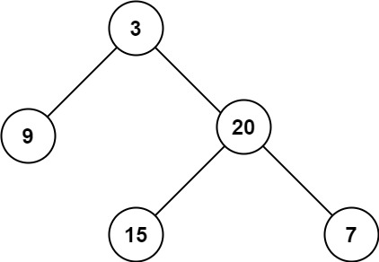

**Input:** root = [3,9,20,null,null,15,7]

**Output:** 3

**Example 2:**

**Input:** root = [1,null,2]

**Output:** 2

**Constraints:**

* The number of nodes in the tree is in the range [0, 104].
* -100 <= Node.val <= 100

Link: <https://leetcode.com/problems/maximum-depth-of-binary-tree/>

class Solution {

public int maxDepth(TreeNode root) {

if (root == null) {

return 0;

}

int leftDepth = maxDepth(root.left);

int rightDepth = maxDepth(root.right);

return 1 + Math.max(leftDepth, rightDepth);

}

}

